Beginner’s Cheat Sheet! | 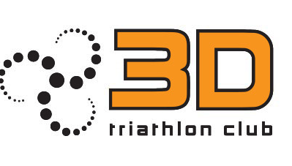
The triathlon distances
Distance | Swim | Cycle | Run
Super Sprint / Try-a-Tri | 400-500m | 15-20k | 3-5k
Sprint | 750m | 20k | 5k
Standard / Olympic | 1,500m | 40k | 10k
Half/ Half Ironman / Ironman70.3 | 1,900m | 90k | 21k
Full / Ironman | 3,800m | 180k | 42k

- 80-90% of all triathlons in Ireland are Sprint or Olympic distance
- www.triathlonireland.com - your one-stop shop for race entries and what’s going on triathlon related in Ireland

The jargon!
Transition | The fourth discipline of triathlon. Getting slick at the transition from swim to the cycle called T1 and the transition from the cycle to the run (T2) is an art in its own right. Sprint triathlons are often won and lost in transition.
Brick session | A cycle followed by a run session to prepare your legs for the jelly like feel of running after a hard cycle.
TT-Bike | The top end bikes with cow horn handlebars used to get an aerodynamic position on the bike.
The Bonk | More than just a fun night in! This is when your blood sugar levels drop suddenly due to intense exercise and lack of sufficient water/food. Avoid it by getting your nutrition plan right especially during endurance training and racing.

The equipment & costs
Swim | - Wetsuit, goggles and a hat | ~ €150-200
Cycle | - Racing bike and helmet | ~ €800-1200 (check the ‘cycle to work’ scheme)
Run | - Road running shoes | ~ €70-100
Race Clothing | - The best option is a tri-suit | ~ €65 (3D club suit)- €80

But don’t be shy! Get on to the 3D website or Facebook and ask for any second gear that might be going!
You might get a great bargain.

Getting started - a few recommendations
1. Get a Check-up - triathlons are achievable for practically everybody, but they place demands on a number of different parts of the body in quick succession, so a quick check-up is very worthwhile.
2. Give yourself enough time - for every hour of endurance sport like triathlon you will probably need to train for between 5-7 weeks (rough average). So, with a typical olympic distance triathlon taking about 3 hours, you should probably give yourself between 15-21 weeks to train depending on fitness, when you start training and other factors.
3. Join a Triathlon club early in the year - you know the one!
4. Training plan - get a plan that makes sense for you and your lifestyle. Talk to your club coaches about this.
5. Pick a race and plan your season!

