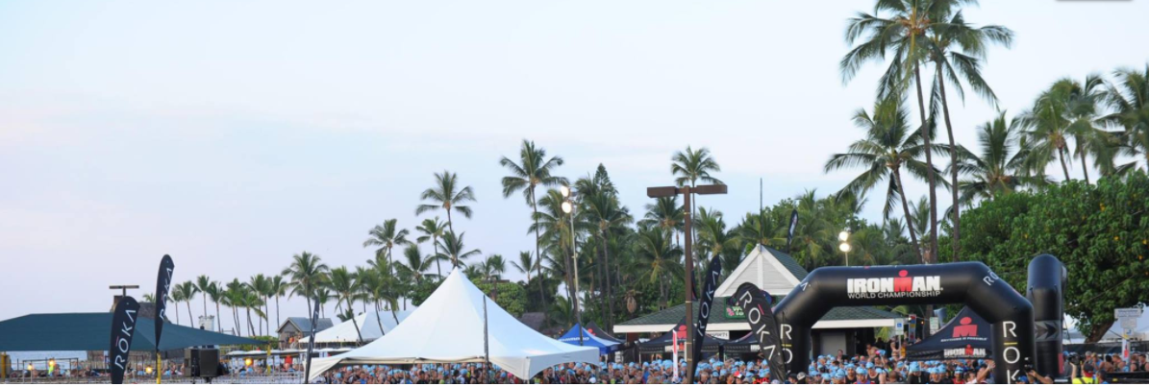
Alan Kenny - Kona 2017
SATURDAY, 28 OCTOBER 2017
Ironman World Championship 2017
Swim
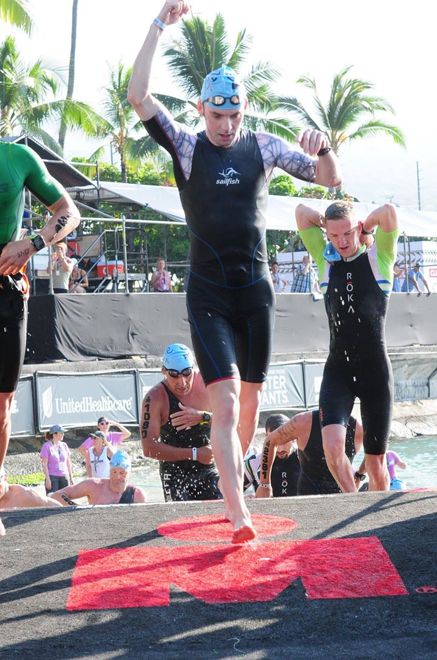

Exiting the Water After an Average Swim
I talked to Bryan McCrystal after the The Lost Sheep and asked him what approach he had taken to the swim in Kona last year. He basically told me he got up right at the front, stubbornly held his position, and braced himself for an hour of getting lumps knocked out of him. Owing to this approach, he said he got dragged along and exited the water in a much faster time than he would have been capable of swimming on his own.
Whilst swimming a fast time sounded wonderful, I wasn't prepared to put myself right in the thick of things in pursuit of it. I figured 60 minutes swimming in such close quarters to hundreds of others wouldn't have left me feeling too fresh for the bike. I never before had so many fast swimmers around me and I wanted to reap the benefits of drafting off them, but I didn't think I needed to get the sh!t knocked out of me to achieve this.
Peter Kern had contacted me on the eve of the race and advised I look at how the pros swam to determine the best starting position. Bryan McCrystal had advised starting on the right and those racing today advised that the further left you started, the less of a beating you'd have to take. The pro men split into two distinct packs, so looking at them was no use in helping me decide where to start. With all the above advice rattling about my head, I couldn't make up my mind and just decided to start in the middle.
After entering the water, I took up my chosen position, but spent a long time treading water thereafter. The group of waiting swimmers were drifting forward and I was losing my position. I was acutely aware I was surrounded by some of the best AG swimmers in the world and it was possible there were some people certain to break an hour going ahead of me. But I felt I was already conceding ground by not starting in the very front row and that was as much of an advantage I was prepared to give anyone. I swam back to where I had originally positioned myself and soon enough the cannon went and the beginning of the end of this odyssey started.
I was expecting there would be absolute mayhem. My only previous experience of a mass start was at Ironman Mallorca in 2014. It was like a fish farm that day, where the rough and tumble went on for half the swim. I thought it was going to last twice as long today, but despite similar numbers taking part in both races, it was nothing like that. Perhaps this was due to having so many evenly matched swimmers in the water together. The competitors seemed to know how to swim civilly in such close proximity to others and the race took its natural order much quicker than it had done three years ago in Mallorca.
In anticipation of a fairly physical swim, I started off swimming at near maximum intensity. The physicality was fairly minimal though and no worse than lots of races I've done back in Ireland. And to be honest, there are many races I've done at home where things were much worse. I was a little bit shocked by how easy a time I was having and I was starting to think it might make sense to ease up a little earlier than I had planned. I figured I was well able for a few more minutes of effort and I chose to continue working hard, hoping to optimise my chances of finding a faster set of feet to draft off. I wasn't getting away from anybody though and decided to back off and to work with the people around me.
This seemed to be a good decision and I got to the turnaround without expending too much energy. Although I wasn't able to see the big huge boat that marked the turnaround point for a long time, I still thought I'd swam a straight line in getting there. When I got within 20m of the this point, I upped the effort until rounding the next buoy on the course that marked the point at which we could start heading back to land. I'm not sure there was any point to this, as there was no congestion and nor was there any real need to escape the group I had been swimming with.
Whatever about that decision, I messed up after making it and ended up swimming on my own with no one to draft off. With so many people taking part, this shouldn't have happened and it took me too long yo figure out I'd gone wrong. I'd swam too far to my left and I had to swim about 200m with no draft to get back in contact with the majority of swimmers. No doubt this cost me a bit of energy, but there was no point in worrying about it.
Apart from my poor navigation, it was an incident free swim and I made it to the exit rather surprised at how comfortable the first 3.8km of today's race had been. I stood up and saw 1:08 on my watch. It certainly wasn't a brilliant time, but based on times previous Irish competitors swam here, my own expectations were somewhere between 1 hour and 1 hour 10 minutes, so it wasn't a complete disaster either.
Time: 01:08:59
Race Time: 01:08:59

T1
I decided to stay calm and collected amid the mayhem that was surely going to unfold here. It turned out I was way too Zen like and the resulting time I lost was ridiculous. Owen Martin had advised putting on shoes in T1 and I heeded his advice. I've no regrets about that decision though and in addition to putting on my cycling shoes, other items of clothing I put on were arm coolers, gloves and worst of all knee-length compression socks, which although practically brand new, I still ripped when pulling them up over my calves. I knew all this was going to take time and I was prepared to accept a slower T1 if it meant comfort on the bike.
The changing tents were very, very busy; the curse of being an average swimmer in a field of thousands. They had equal sized male and female changing tents despite the fact there were 1,000 more males competing. And with the female wave starting 15 minutes after the males, it meant there were only a handful of females in that half of the tent when hundreds of men were fighting for a seat in my half. Initially, I didn't bother trying to find a seat and I emptied my cycling bag onto the ground beside a table. My plan was to get changed whilst standing, but with multitudes of people still flowing past, this was proving incredibly difficult. When I went to put on my socks, I realised it wasn't going to work and I gave up on the idea of getting changed here. I picked my gear up off the ground and ran through the tent looking for a free chair. When I found one, I unceremoniously plonked my arse down and was able to get changed without the worry of somebody charging into me and knocking me over.
When I was finally ready to go, I stood up and ran to my bike as fast as my cycling shoes would allow. Fortunately it was racked in an easy position to locate and I found it without trouble. I was guided out of T1 by the numerous marshals present and across the mount line. Before pressing the lap button on my watch, I had a quick glance to see how long I had taken transitioning. "Nearly 8 minutes, f*cking hell!", I thought. I knew I had been slow, but I didn't think I had been that slow. Unlike the swim, this was a disaster.
Time: 00:07:49
Race Time: 01:16:48

Cycle
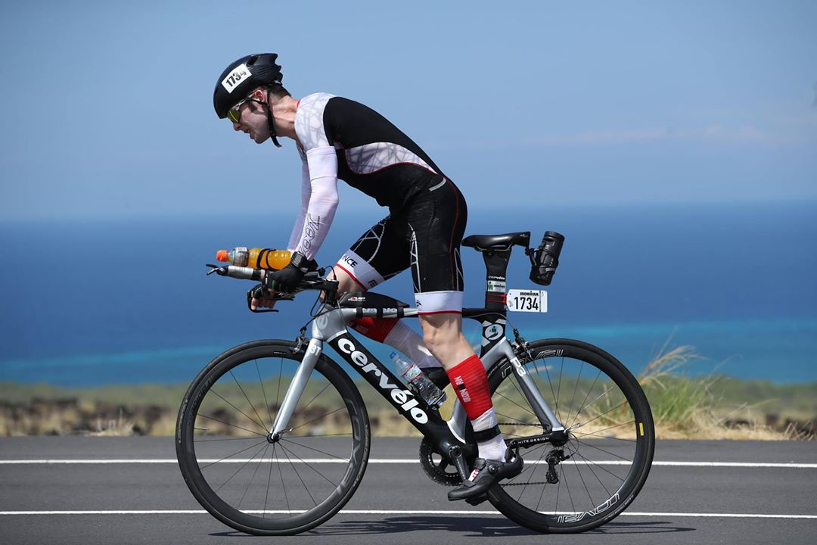
Push, Push, Push!
I hadn't yet given up on my sub 9:10 goal, but I knew to achieve it now would take a pretty epic bike split backed up by a not too shabby run. From here, it was a case of 'Giddy up! There's work to be done.' Unfortunately I couldn't get down to work straight away. The roads were so busy, it was impossible put out a maximum effort. I was prepared for this, but still it was a frustrating wait until we reached the Queen K Highway where the road opened up and it was essentially 50km of straight road.
With so many people on the road, it was hard to pass safely and I probably erred on the side of caution in staying behind slower cyclists rather than overtaking them. A few others didn't seem as concerned about their own or other's safety as I was, and performed what I deemed were risky overtaking maneuvers. After another three or four cyclists did the same thing, I thought 'Fuck it!' I wasn't prepared to lose any more places while others benefitted from me playing it safe. I followed the next guy who went by and let him shout out warnings to the slower cyclists we were passing.
We got to Palani Road, a short incline before we turned left onto the Queen K. The bunches started to splinter and I chose this as my moment to put the boot down. I began passing people right away. At the top of this incline, I turned onto the Quenn K and from here it was a case of 'Push, push, push!' all the way to the turnaround at Hawi.
I was passing lots of people, some in bunches making no effort to get out of them. If it was completely ridiculous, I'd make a comment as I went by, but it didn't bother me too much to be honest. I was moving faster than all of them working together and I would have backed myself to stay away from them all on the run. I didn't feel like they were cheating me out of anything. It might be naive of me, but I feel to do well in Kona, you need to be strong enough to race your own race from start to finish and I'd like to believe the top AGers weren't riding in packs like the ones I was passing.
Aid stations were well positioned and I was passing them regularly. I've really no idea how much I drank, but I felt like I was hydrating sufficiently. I grabbed a bottle of water at most of the aid stations. I'd chug some of the ice cold water and pour the rest if it over myself. I don't think I was dehydrated, but at the same time, I don't remember p!ssing even once on the bike. I wouldn't have expected to go 5 hours without needing a whizz, but I was obviously sweating a lot and maybe that's where the fluids were being lost. I wasn't worried about things, but the longer I went without p!ssing, the more I wondered if I was drinking enough.
I started off with 5 gels and a shot of caffeine in my food pouch and had them all consumed by the time the climb to Hawi started. It hadn't occurred to me to restock before my fuel ran out. As I sped past an aid station after inevitably running out of fuel, I failed to grab a gel and it occurred to me how stupid this had been. I'd an almost full bottle of Gatorade though and I consoled myself that this would be enough fuel until the next aid station, when hopefully I'd manage to grab something more calorie rich.
There was only one table at each aid station handing out food, as opposed to four of them handing out drinks. The food table was right in the middle of all the other tables and was always the most congested. The table where I'd failed to grab any sustenance was manned by kids, who didn't seem to know how to hand stuff to moving cyclists. So I was getting a little bit worried about my predicament. Thankfully though, I successfully grabbed a half empty pack of Clif Shot Blocks (I'd have said half full if I had been in a more optimistic mood) at the next aid station I passed, some more Clif Shot Blocks at the second one and then praise to 'whatever gods may be' two gels at the third one I passed, and my brief moment of panic was well and truly over.
Despite missing a gel and with it a scheduled fuel intake, I felt fresh enough after surmounting the climb and reaching the turnaround in Hawi. There was a long descent coming up and with it a good opportunity to recover. The course got very fast in parts from here and there were some gusts of crosswind. Any stronger and they could have potentially led to some scary moments. As it was though, they weren't hugely worrying and for the most part I was able to stay on my tri bars all the way down the hill.
Unfortunately I lost a few places here. It was the first time in the whole cycle that people had passed me and were able to get away. Unlike the descent in Mallorca last year, this had nothing to do with my bike handling. It was the most straightforward descent I've ever done and I simply ran out of gears. I was riding a 53-39 and I could do nothing about the people zooming past generating more power from bigger big rings. It was a waste of time pedalling at times and all I could do was note the kit of the six or so people who had gone by and derive some satisfaction from the fact that I caught and passed them all once gravity became less of a factor.
Despite losing a few positions, I'd still made up good time on the descent and from here I was doing frequent calculations as to whether a sub 5 hour bike split was going to happen. The wind wasn't helpful, but it wasn't having as big an impact as I had feared it might and the more kilometres I racked up and the closer I got to 180km, the more likely a sub 5 hour split seemed.
Even though I was moving up through the field and logical thinking would suggest that the cyclists further up would have been stronger than those I'd passed earlier, I was having no difficulty passing anyone. I was surprised by how quickly I was distancing them as well and I started to believe this could turn out to be the race of my life. I rode by the airport and was out of the lava fields. I was less exposed to the winds now and bar mechanicals, I knew for certain sub 5 was going to happen. Now it became a case of how far under the 5 hour mark I could get.
I got back to Kailua, but there were a few turns and steep downhill sections to negotiate on the approach to transition. I didn't want to come this far without incident, only to fnck things up with a spill off my bike. I took it easy going round the bends and avoided gathering too much speed going downhill. Transition came into view and after a 4:54 bike split, I safely arrived at the dismount line in a total race time of 6 hours and 10 minutes.
Time: 04:54:06
Race Time: 06:10:54

T2
It was going to take a lightning fast transition followed by one hell of a run to break my original goal of 9:10. I knew this was going to be next to impossible, but I still thought sub 9:15 was doble, which I still would have been pleased with. I needed to get out of T2 in a much hastier fashion than I had managed in T1 though. Having not done the classic tri dismount by taking my feet out of my shoes, I was now running along in my cleats; not a great start to a "lightning fast" transition.
I saw others running along with cycling shoes in hands, so they had obviously stopped somewhere between the dismount line and here to take them off. Worried that I might be penalised for stopping in the flowzone, I asked a marshal was it okay to stop and do the same. He gave me the go-ahead, so I knelt down and took my shoes off. After this, I proceeded to the changing tent and thankfully my legs were cooperating. Not everyone seemed to be in as big a rush as I was and I had to excuse myself as I barged past people moving at barely more than a walking pace.
After grabbing my run bag, I was straight into the change tent. Thankfully there were a lot more free chairs than there had been in T1 and I had plenty of choices of where to sit. Whilst sitting, I got a volunteer to daub sunscreen on my neck. From having put on so many items of clothing in T1, I didn't have a whole lot to do now; simply put both runners on, take off my helmet, put on a visor and I was up and running. I passed a drinks table on the way out and briefly stopped to knock back two cups of Coke. Then I was out of the tent and across the timing mat. Now the race was really and truly on.
Time: 00:03:51
Race Time: 06:14:45

Run
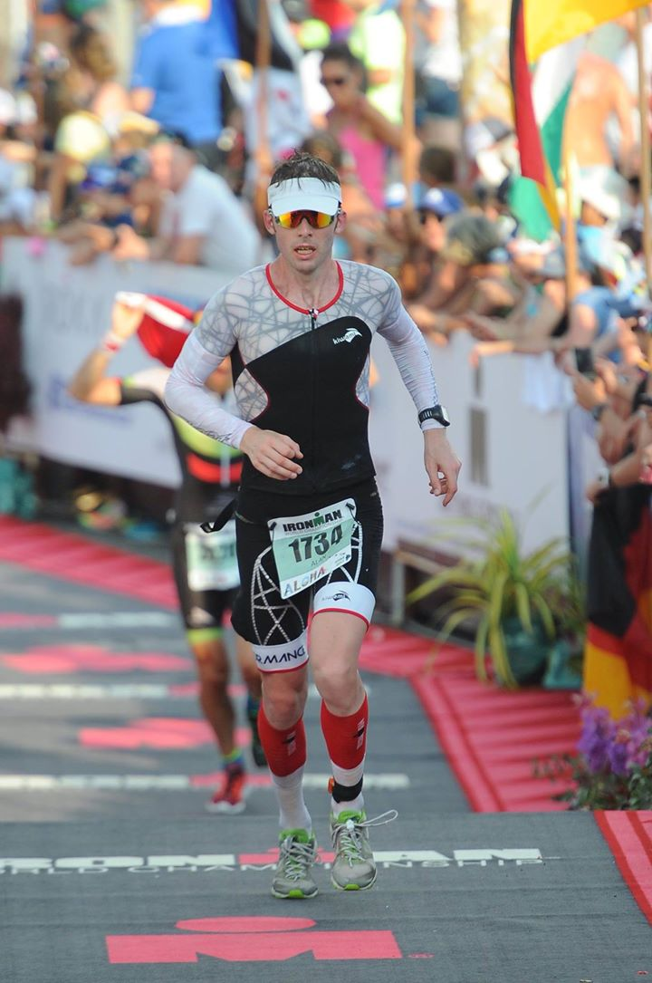
5 Metres to Go; Pain Almost Over
Race Time: 06:14:4 showing on my Garmin was total race time and overall race distance. Wth such little info on display, I was just running on feel. I was covering ground quickly enough and continued the trend of consistently passing people just like I had been doing on the bike. Nobody had passed me either and I presumed I was moving further and further up my age group. I wasn't 100% sure of the time I started running, but I calculated that I covered the first 5km between 20 and 21 minutes. This was well under sub 3 pace, but I was feeling good and thought I was going to be able to keep it up.
I hadn't fully thought out my fuelling strategy and I made a few mistakes that I shouldn't have. I stopped taking gels and was only drinking Coke and Red Bull for calories. I've learned the hard way before that no matter how unsettled your stomach might seem, it is sometimes more important to just get calories on board. Come the end of the race, I think today was one of those times. I stubbornly stuck to Coke and Red Bull however, despite the fact that I spilt the majority of the contents of the cups I was trying to drink from.
I was determined to run every step of the marathon today and I wasn't slowing down through the aid stations. This combined with the congestion at the stations, meant I missed a good few opportunities to grab sponges, ice and drinks. Missing the drinks meant I was ingesting even less calories than I'd planned and taking a few gels might have made up for the calorie deficit I was putting myself in. Any cups of ice I grabbed went straight down the front of my top, when I now think it might have been more useful to empty them down my shorts, to prevent the hardest working muscles in my legs from overheating.
I was slowing, but I wasn't in any great discomfort and I thought it was just my legs naturally settling down to a more sustainable pace. I was starting to feel the heat when I got back to Kailua almost 10 miles into the marathon and I knew that some discomfort lay just around the corner. This literally turned out to be the case and the discomfort arrived the moment I rounded the next corner and began running up the almost infamous hill that is Palani Road. The first inkling of cramp in my left adductor arrived and the temptation to walk was massive. Like I said earlier, I hadn't planned on taking any walking breaks and I knew had I walked this early on, it would have set a dangerous precedent.
It was with a sense of relief that I got to the top of Palani Road still running and turned left onto Queen K Highway. It was a long lonely road out to the second turnaround point at The Energy Lab. Running most of this section on a training run on my second full day on the island, helped prepare me for this stretch. I maintained a respectable speed for as long as I possibly could. The pain was increasing though and it began to feel like it would only be a matter of time before debilitating cramp struck.
The urge to walk was growing and growing, but I knew succumbing to this would be the death knell of achieving a good time. Overheating was becoming a major issue and I was on the lookout for a promised Hot Shot aid station on the road side. I'd heard wonderful stories about the instant relief from cramp this drink provided. So when I got to their station, I was prepared to take the time to stop and make sure I knocked an entire bottle down my throat. I'm not sure about the merits of the claims made by Hot Shot, but the drink was so disgusting, it provided some sort of distraction from my impending cramps.
After downing this vile concoction, I was passed and definitively distanced for the first time in almost 7 hours of racing. I tried to convince myself that this guy must have been a good runner, but how it happened was more than a little bit humbling and I didn't honestly believe that assessment to be true. There was no other reason for it other than me slowing down. A few more runners passed me before the Energy Lab and at this stage, I forgot about position and finishing time and just wanted to make it to the finish line without having to walk. I wasn't too concerned with speed either as long as I kept moving forward in a running motion.
I turned off the Queen K and into the Energy Lab. I was matching pace with another guy for a few hundred metres. Up until now, I had been pretty much ignoring the other athletes, but I had started to run in step with this guy and it would have seemed a small bit rude not to acknowledge him and we engaged in some polite small talk. Through this, I found out he was aiming for a 3:30 marathon and he was happy with the pace he was running. This wasn't what I wanted to hear and I knew I had to speed up. I slowly pulled away from him, but I think this had more to do with the other guy falling off his 3:30 pace, rather than me getting faster.
I got back out onto the Quenn K and tried to draw some encouragement from the fact that I knew the majority of the road home was mostly down a gentle and gradual decline. Mentally I'd broken the run down into 15 minute segments, thinking if I can just get through 15 minutes at a time without walking, I'd be 15 minutes closer to the finish and have 15 minutes less time fighting the temptation to walk. I'd been doing this from 8 hours onwards and although my "run" might well have been classified as a jog, I was still moving forward in a running motion. Through this strategy, I'd made it to 8:15, 8:30 and 8:45 still "running".
I can't quite remember if I made it to the 9 hour mark, but it was around here my legs just packed it in and I was brought to an instant stop. I couldn't even walk to an aid station that was a mere 10m away. As painful as it was, I managed to stretch and I hobbled on to the aid station. Here I slugged a few drinks and threw ice down my shorts. The relief was immense and it occurred to me that I should have been doing this and keeping my leg muscles cool all along. The realisation came too late today, but it's something to remember if I'm ever back.
After this episode, I decided it would be wise to walk the aid stations from here on in. Finishing time was no longer a motivating factor and I just wanted to get to the finish line with as little discomfort as possible. Walking through the aid stations would mean I would no longer spill half the drinks over myself. I could get ice down my shorts and I'd no longer get frustrated by other people snatching drinks from the hands of volunteers just right before I did.
All the while I was getting passed regularly and I lost a lot of places over this final 12km. I'd stopped caring though and I was just trying to focus on my own race, which at this point was just about putting one foot in front of the other. Anytime I tried to run faster, the threat of cramp seemed to grow. Short steps seemed to be the way to go. I passed the Hot Shot station once again and hoping for a miracle cure for the cramps that were ruining my race, I knocked back another of their magical concoctions. If not cramping for 2 minutes is proof their products work, then they do, but two minutes later I was once more unable to move and grimacing in pain only 2½ kilometres from the finish.
I slowly got moving once more, but I was getting passed again and again and I could offer no resistance. I got down Palani Road and knew the finish line was coming soon. Although I'd forgotten about finishing time, I was still regularly looking at my watch. If I could muster some sort of sprint finish, breaking 9:30 might have been possible. One final seizure, within 1km of the finish line, put paid to that though. After this, it took me about 20 seconds to get going and all I wanted now was not to seize up and stop in the finishing chute. I was passed one last time, but thankfully I made it across the line without cramping in the last 100m.
Time: 03:16:46
Race Time: 09:31:29

Reflection
I still don't know how to fully assess the race. I finished something that had been a goal of mine for years, but it hasn't brought with it any sense of closure. There certainly aren't any feelings of joy or triumphalism. The marathon broke me and while 9:31 might not be a bad result for one's debut in Kona, I feel I was capable of much better than this. I lost a lot of time over the last 12km of the marathon and from kilometre 36 onwards, I was haemorrhaging it.
The following is not to downplay anyone else's performance; The guy I reference paced things a lot better than me, so chapeau. Nor was my motivation to be the fastest Irish finisher this year, but just to highlight how bad my time losses were; I was 4:40 ahead of Colin O' Shea, the fastest Irish guy on the day, after 22.3km of the marathon. If I could have held this gap, I would have been 14th in my AG, which has a much better ring to it than 31st. Instead, I ended up finishing 3:48 behind him. It's hard to feel anything but regret when I ponder that.
Needless to say, this is not how I had planned my race and I crossed the finish line with no real sense of satisfaction. I am however happy with the approach I took. Perhaps I over biked, perhaps I started the run too quickly, I definitely showed a huge amount of naivety, but I staked my whole race on going as fast as I could for as long as I could. I put it all on the line and once on the bike, I attacked from the get go. It's how I like to race and I'm glad I stayed true to this principle.
Where I'll go from here, I'm not sure. I've raced in Kona, which everyone who is reading this should know was a long term goal of mine, but as I've said previously racing there doesn't feel like the end of the journey. I realise I am lucky to be fit, healthy and able bodied. If you want to extend that to say I am lucky to be able to do Ironman, then I'll accept that, but I didn't feel lucky to be taking part in what for many triathletes is the Holy Grail of the sport. I'd earned the right to be there and I wasn't overwhelmed or blown away by anything I saw during my two and a half weeks on the island. I didn't buy into the whole hullabaloo that surrounds the race. I didn't get excited by seeing the pros training. To be honest, I wouldn't recognise 90% of them anyway. I was there to do my own race and it didn't matter to me that some of the most famous names in triathlon were also taking part.
Dig Me Beach was definitely a nicer place to swim than the Irish Sea, but I didn't get excited about the pods of dolphins that were in the water with me. I didn't see any turtles, but I'm sure my feelings would have been the same had I seen one. I didn't go to Hawaii for a holiday, I was there to race and everything else was incidental. Maybe that's not showing the race the respect or the reverence it deserves, but I'll still have the same attitude if I ever go back. I tried to treat it as just another race and it's one I don't think I did myself justice in. I still think going sub 9:10 in Kona is an attainable goal.
To do that though, I'll need to keep working on my swim. My progress to date has been gradual and I don't know if this gradual progress is going to be enough to get me to the level I need to be at, but swimming faster and getting out of T1 in less than 1:05 needs to be the objective. As I said previously, my first transition was a disaster and I need to start treating it the very same as T1 in an Olympic distance race. And while 4:54 might be an okay bike split, the reality for a poor swimmer like me is that I need to get that under 4:50. I don't think my run is going to get a whole lot quicker, but then it doesn't need to. The challenge here will be to just to hold things together for 42km instead of 22km. Maybe a more conservative opening 5km might be in order, but I think simply making better use of the aid stations, and having a special needs bag, would have gone a long way to a more comfortable 42km.
It sounds simple when I break it down like that and I don't think there's anything wildly unrealistic about any of those stated ambitions. I'm finding it very hard to let go of this result and there's only one way to put that right. But good lord it will be a long journey and I don't know when, where, or even if, it will begin.

